Docker Task -3

Task Description:

Create a custom docker image for nginx and deploy it using docker compose, where the volume bind mount should be at /var/opt/nginx location. Push the created custom docker image to your docker-hub.

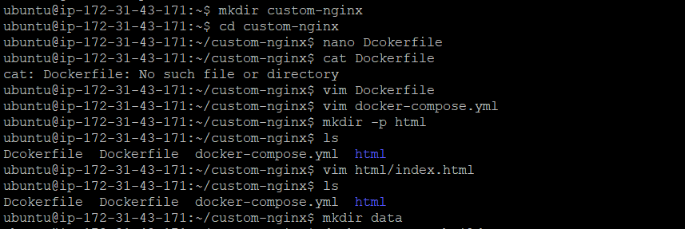

Building Customer Image:

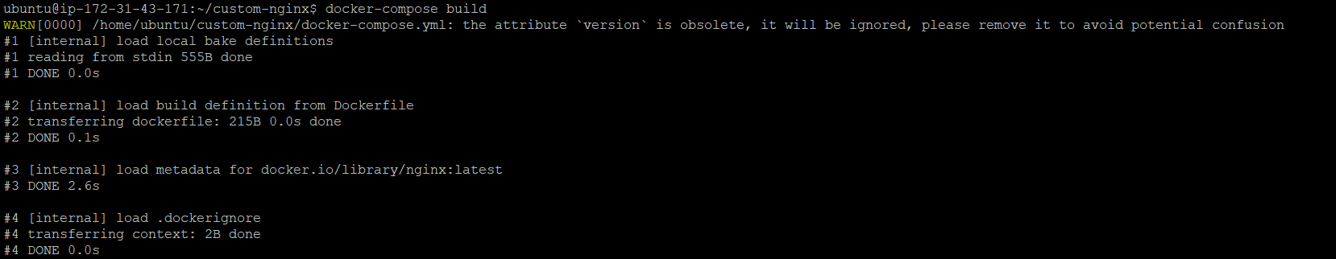

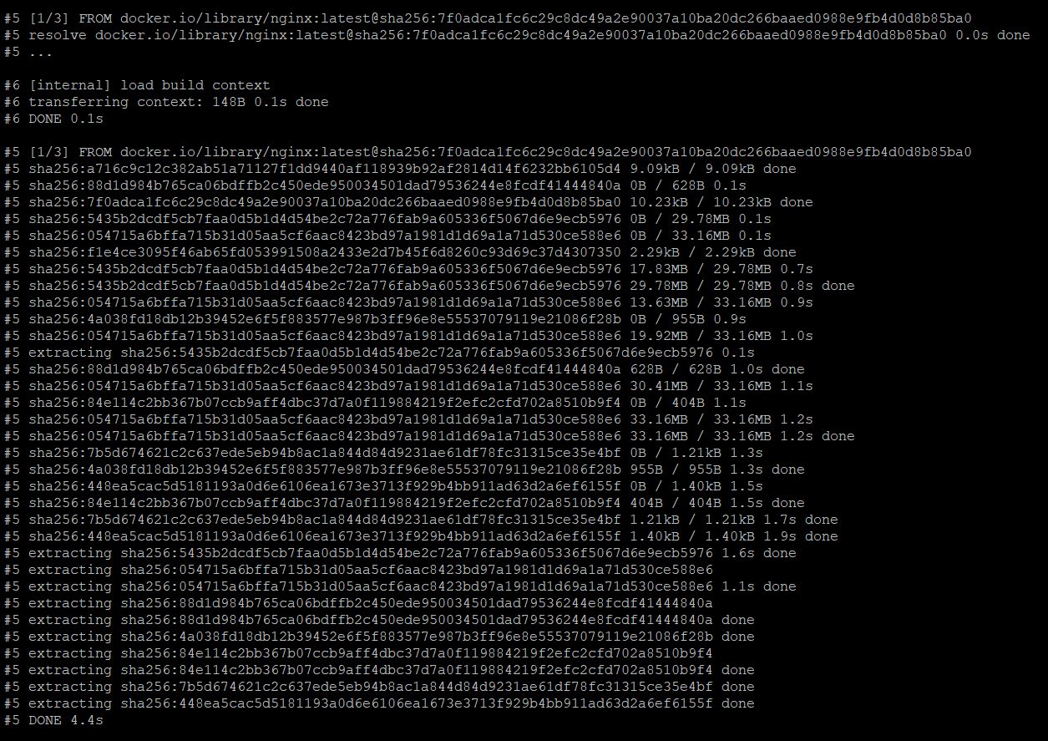

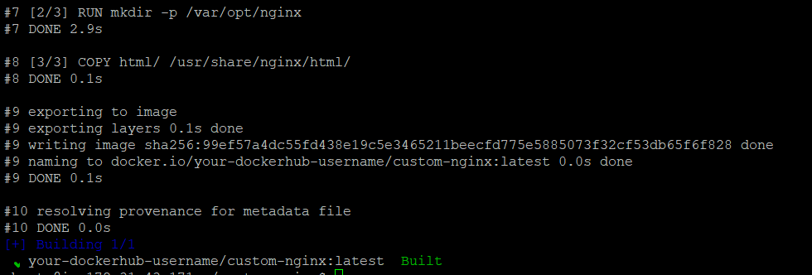

Running Container :

Pushing Image to Docker :

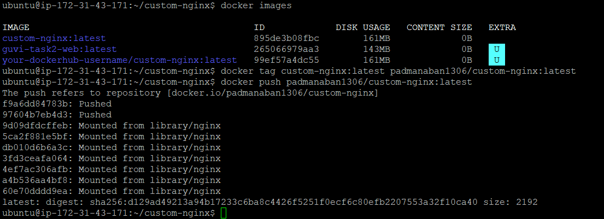

Output:
